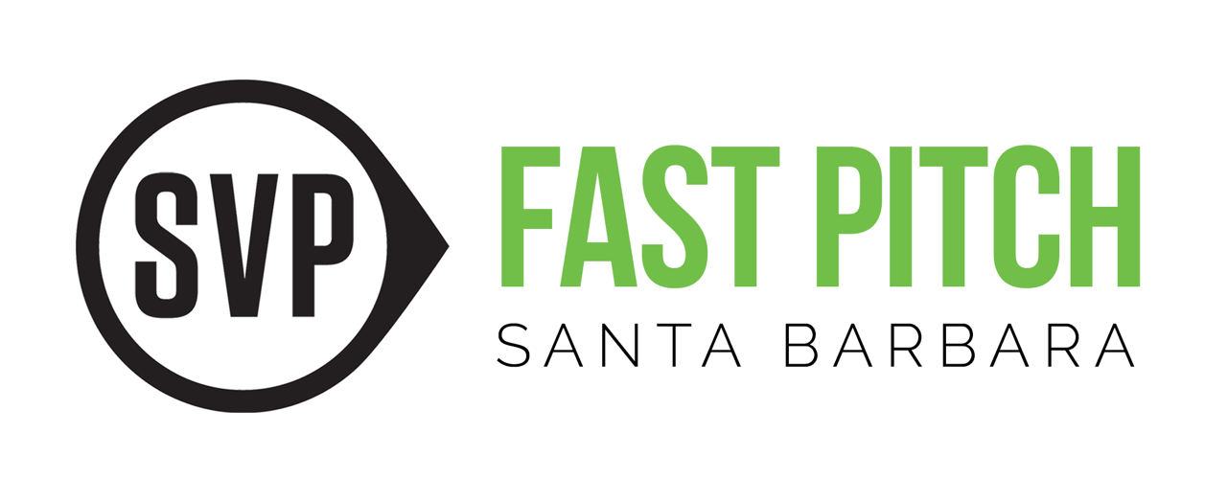
Fast Pitch SB Scorecard 2015

Please turn in your scorecard to Judy Hawkins before you leave today. Thank you.

Engagement: How well does this speaker and content:
- Capture your interest?
- Engage you through stories, data points, questions, emotion, personal touch, or props?
- Demonstrate the results of their approaches?
- Do you want to know more?
About the Organization and Mission: How effectively does the speaker clarify:
- What issue are they trying to solve – what do they do?
- Who do the program(s) serve – clients?
- How do they deliver services – types of program(s)?
- What sets this organization apart? How do they know their work is effective?
Clarity of Presentation: How clear are:
- The delivery of this presentation and information (voice projection, pace, authenticity)?
- The speaker’s ability to minimize or explain use of clichés, industry jargon and acronyms?

Call to Action/ “Ask” – How well does this speaker:
- Present a clear “ask” for support, resources (services, training, facilities) or other action?
- Inspire, motivate or compel you in the call to action?
- Do you want to get involved with this organization now?

Scoring Scale for each presentation element

0 1 2 3 4 5
Did not address Meets Exceeds Criteria Criteria Criteria

Please rate each speaker’s presentation on each of four criteria on a scale of 0 – 5 with five (5) being the highest score.

 | Team Name | Engagement  Score  0 – 5 | About the organiz.  Score  0-5 | Clarity  Score  0-5 | Call to Action  Score  0-5 | Overall Score  Max. score 20
1 | Organization/Speaker Name
2 | Organization/Speaker Name
3 | Organization/Speaker Name | ,

